**Project Name:** Image Color Detection

**Github Link:** https://github.com/projectsforstudents2022/Image_Color_Detection.git

**Why was this project created?**

Color detection is essential for object recognition and is a technique utilized in many image editing and sketching programmes. It is the procedure for identifying any color's name. The challenge that faces us is how to teach a computer to comprehend or recognise colors.

**What problem is it solving?**

The Color Detection Model's goal is to identify the most significant colors in an image. Without physically altering or harming the person's eyes, this endeavor can assist someone who has color blindness. This illness is hereditary and not easily treatable. The person who has this illness is unable to distinguish between colors.

**Entire explanation of project**

* **PROPOSED APPROACH**

Red, green, and blue are the main colors that make up all other colors. Each color value in a computer is defined within the range of 0 to 255. A color can be represented in roughly 16.5 million different ways. We must translate the values of each color to their corresponding names in our collection. We'll be utilizing a dataset that lists the names of the RGB values alongside the values themselves. Using the device's web camera, runtime operations are carried out. We must create an Image Capture object in order to take an image. Following frame-by-frame image capture, we convert each frame from BGR to HSV colour space. OpenCV offers more than 150 different color-space conversion techniques. But we'll only focus on the two that are most frequently used: BGR to Gray and BGR to HSV. We're making a mask with a blue object as its centerpiece.

Then, in order to highlight and save only the objects with blue color, I did a bitwise and on the input image and the threshold image. Since imshow() is a HighGui function, it must call waitKey frequently in order to complete its event loop. A programme function that will return the color of the mouse pointer's click is required. We already know that in order to obtain the color, we must first obtain the distance and then compare it to the dataset.

* **RESULT**

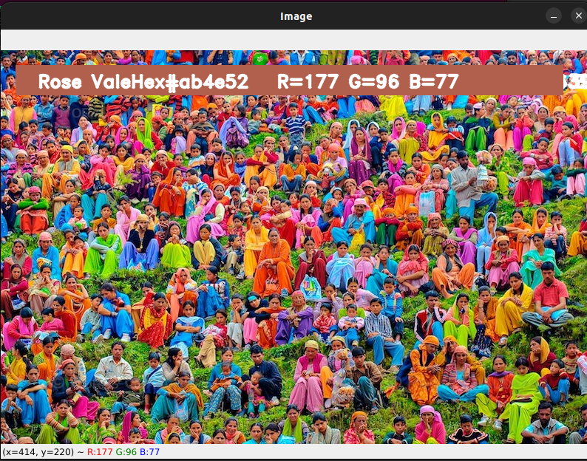

**CONCLUSION**

In this project, we established how to extract the necessary color field from an RGB image. Using the openCv platform, different steps are implemented in this. This method's ability to differentiate between different shades of a single color is its key selling point. This project searches for the composition of the three hues red, green, and blue in the supplied image using the path of the image as input.